

**Course Title:** CSE110

**Section:** 06

**Semester:** Summer 22

**LAB-02**

**SUBMITTED TO**

Mahamudul Hasan

Department of Computer Science & Engineering

East-West University

***SUBMITTED BY***

**Name:** B M Shahria Alam

**Student ID:** 2021-3-60-016

**Date of submission:** 20 June 2022.

P1

package lab2;

import java.util.Scanner;

public class CheckOddOrEven {

public static void main(String[] args){

Scanner input= new Scanner (System.in);

int x;

System.out.println("Process Started");

System.out.println("Enter the number:");

x=input.nextInt();

if(x%2==0)

{

System.out.println("The number is Even");

}

else if(x%2!=0)

{

System.out.println("The number is Odd");

}

System.out.println("Process Completed");

}

}

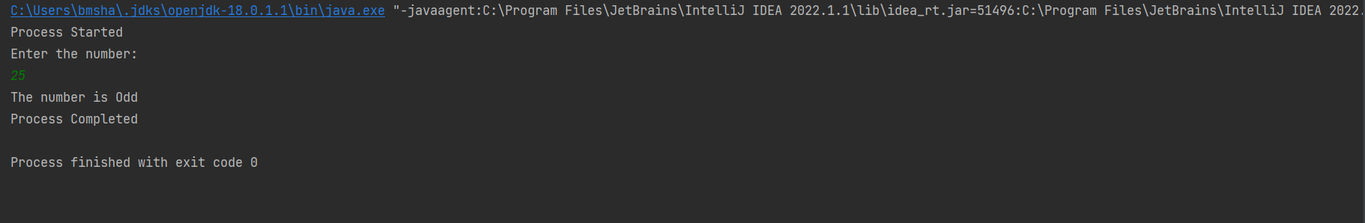

P2

package lab2;

import java.util.Scanner;

public class Fibonacci {

public static void main(String[] args){

Scanner input= new Scanner (System.in);

double sum=0;

int x,y=1,z,i,a=0;

System.out.println("Enter the limit:");

x=input.nextInt();

for(i=1;i<=x;i++)

{

sum=sum+y;

z=a+y;

a=y;

y=z;

System.out.print(a+" ");

}

double avg= sum/x;

System.out.printf("\n"+sum);

System.out.printf("\n"+avg);

}

}

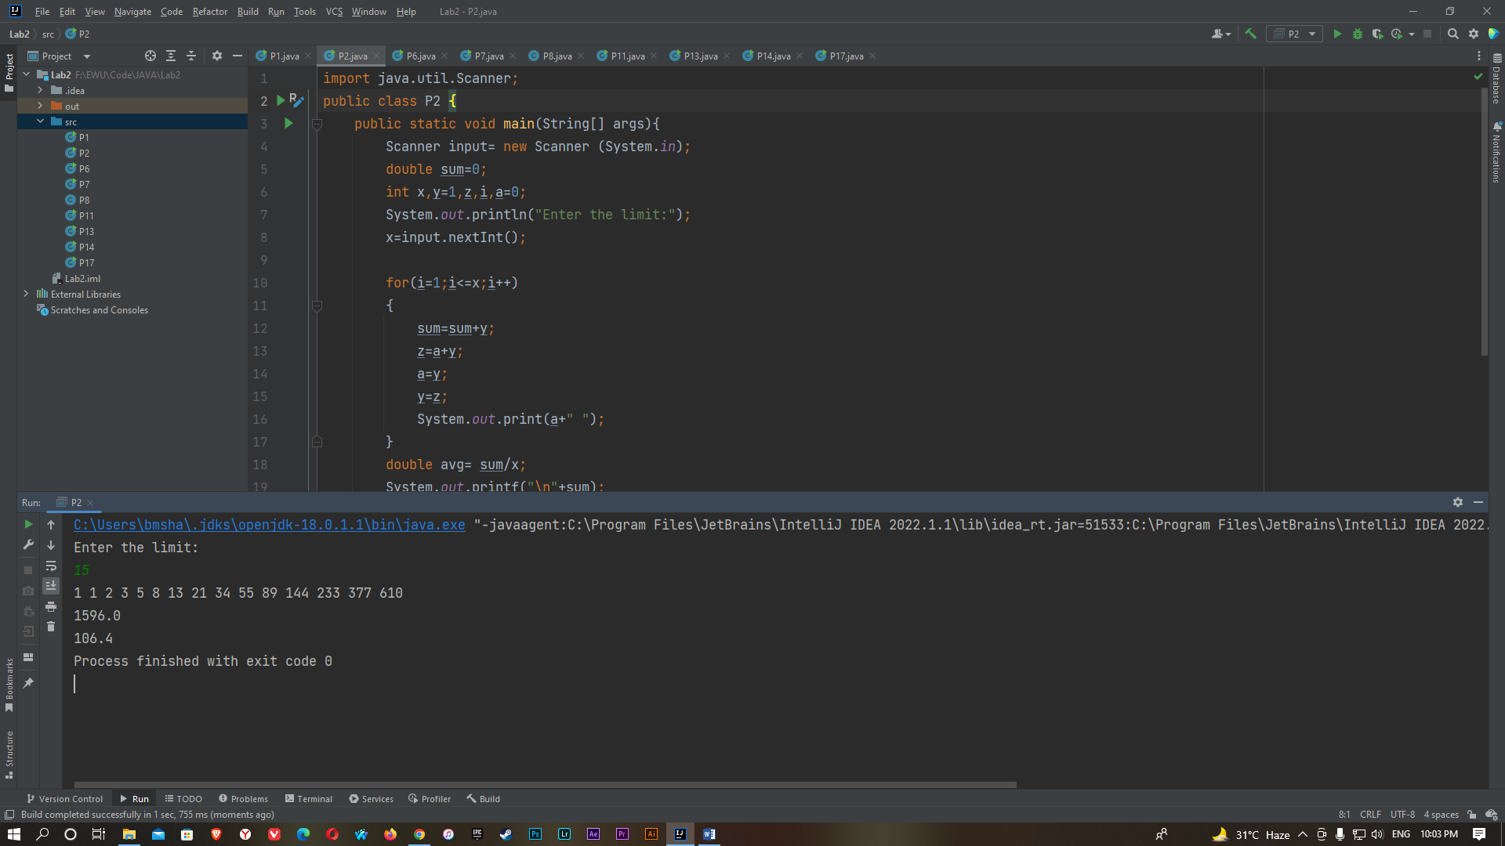

P3

package lab2;

import java.util.Scanner;

public class SquarePattern {

public static void main(String[] args){

Scanner input= new Scanner (System.in);

int x,i,j;

System.out.println("Enter the size:");

x=input.nextInt();

for(i=1; i<=x; i++){

for(j=1; j<=x; j++){

System.out.printf("#");

}

System.out.println("");

}

}

}

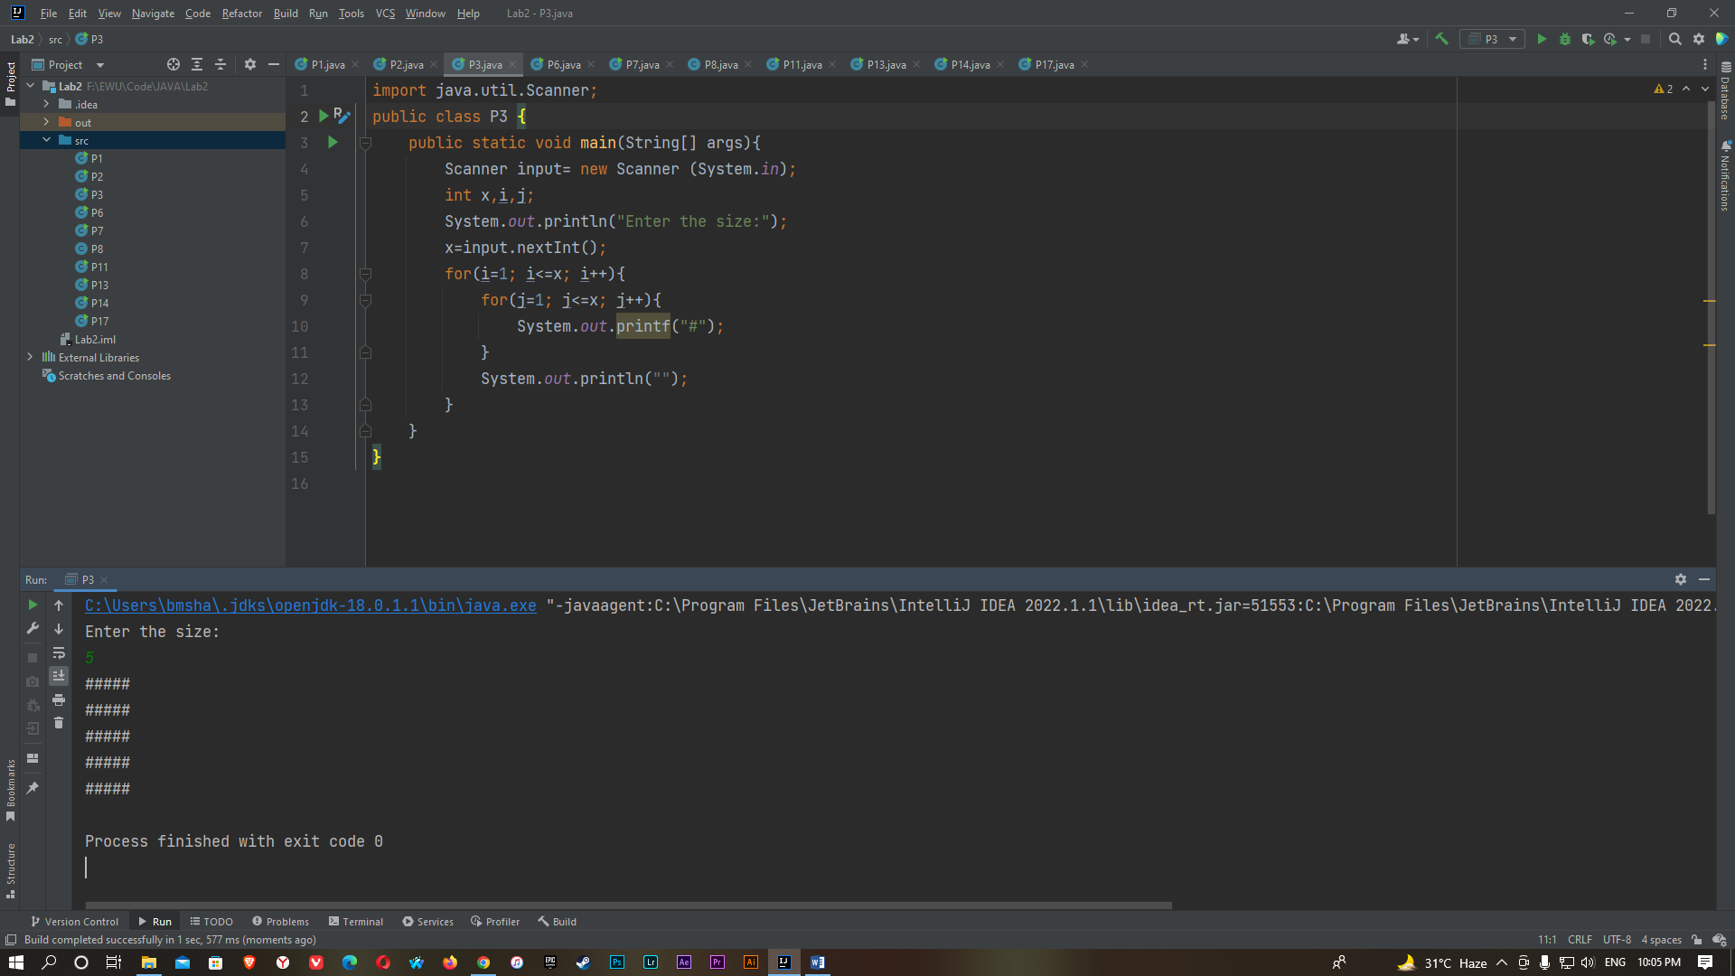

P4

A)

package lab2;

import java.util.Scanner;

public class PatternA {

public static void main(String[] args){

Scanner input= new Scanner (System.in);

int x,i,j,k = 0;

System.out.println("Enter the size:");

x=input.nextInt();

for(i=1; i<=x; i++){

for(j=x; j>=i; j--){

System.out.print(" ");

}

for(k=1; k<=2*i-1; k++)

{

System.out.printf("#");

}

System.out.println("");

}

}

}

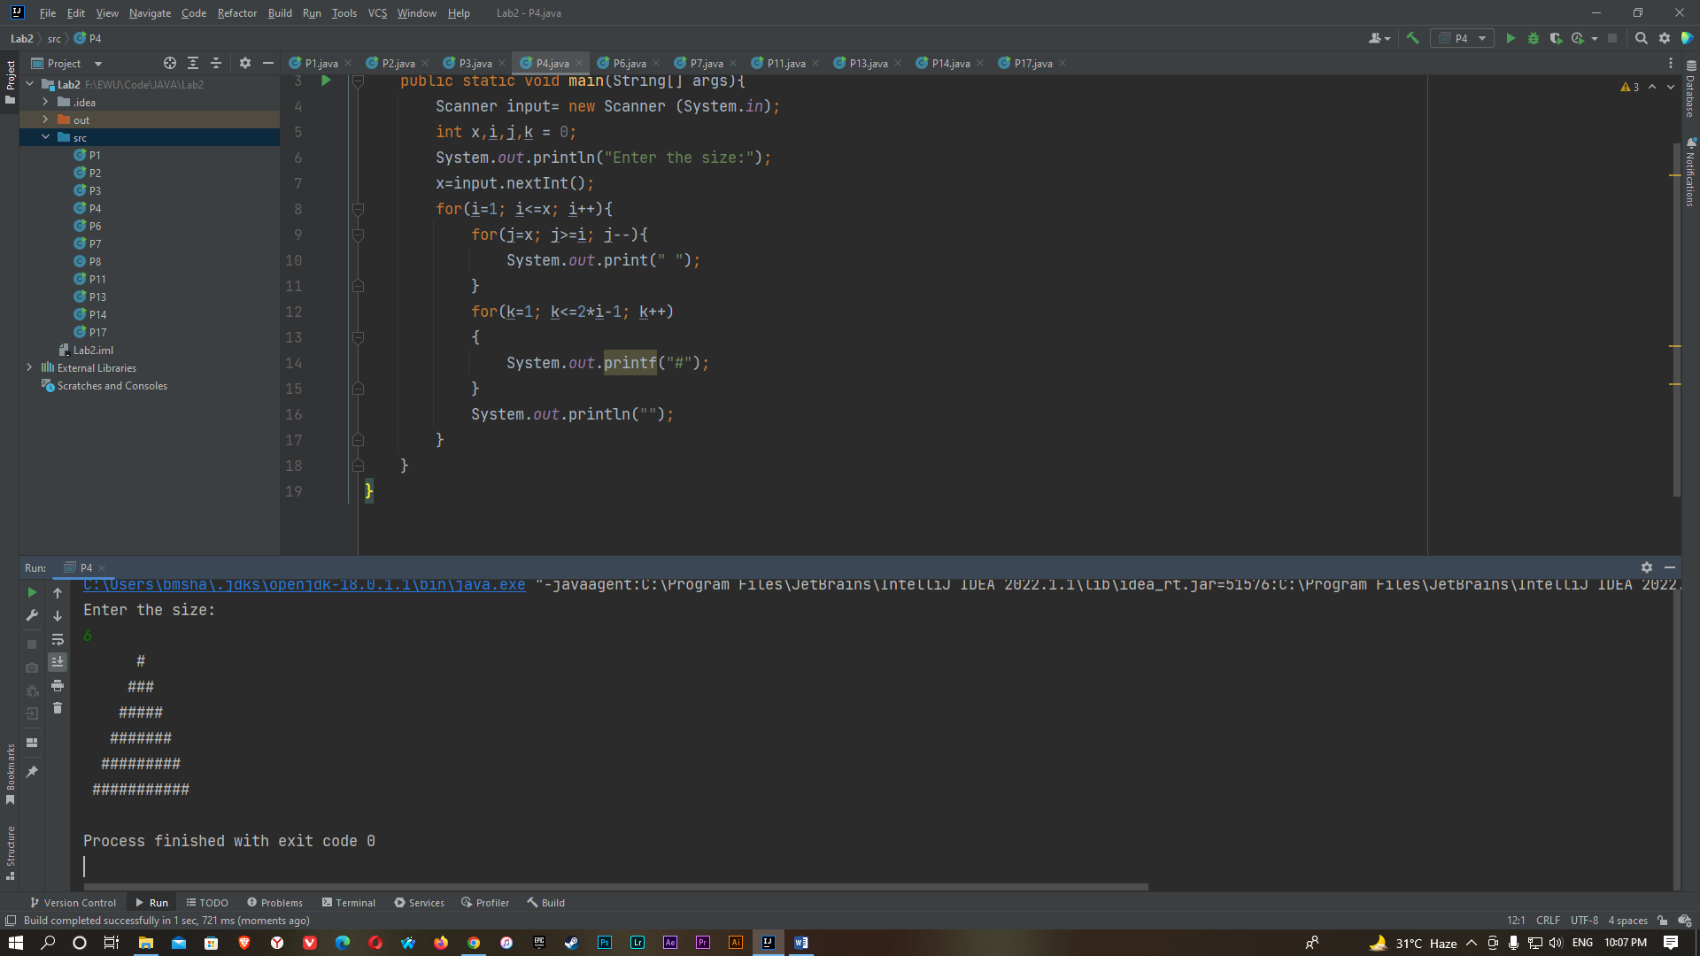

B)

package lab2;

import java.util.Scanner;

public class PatternA {

public static void main(String[] args){

Scanner input= new Scanner (System.in);

int x,i,j,k = 0;

System.out.println("Enter the size:");

x=input.nextInt();

for(i=x; i>=1; i--){

for(j=x; j>=i-1; j--)

{

System.out.print(" ");

}

for(k=1; k<=2*i-1; k++)

{

System.out.printf("*");

}

System.out.println("");

}

}

}

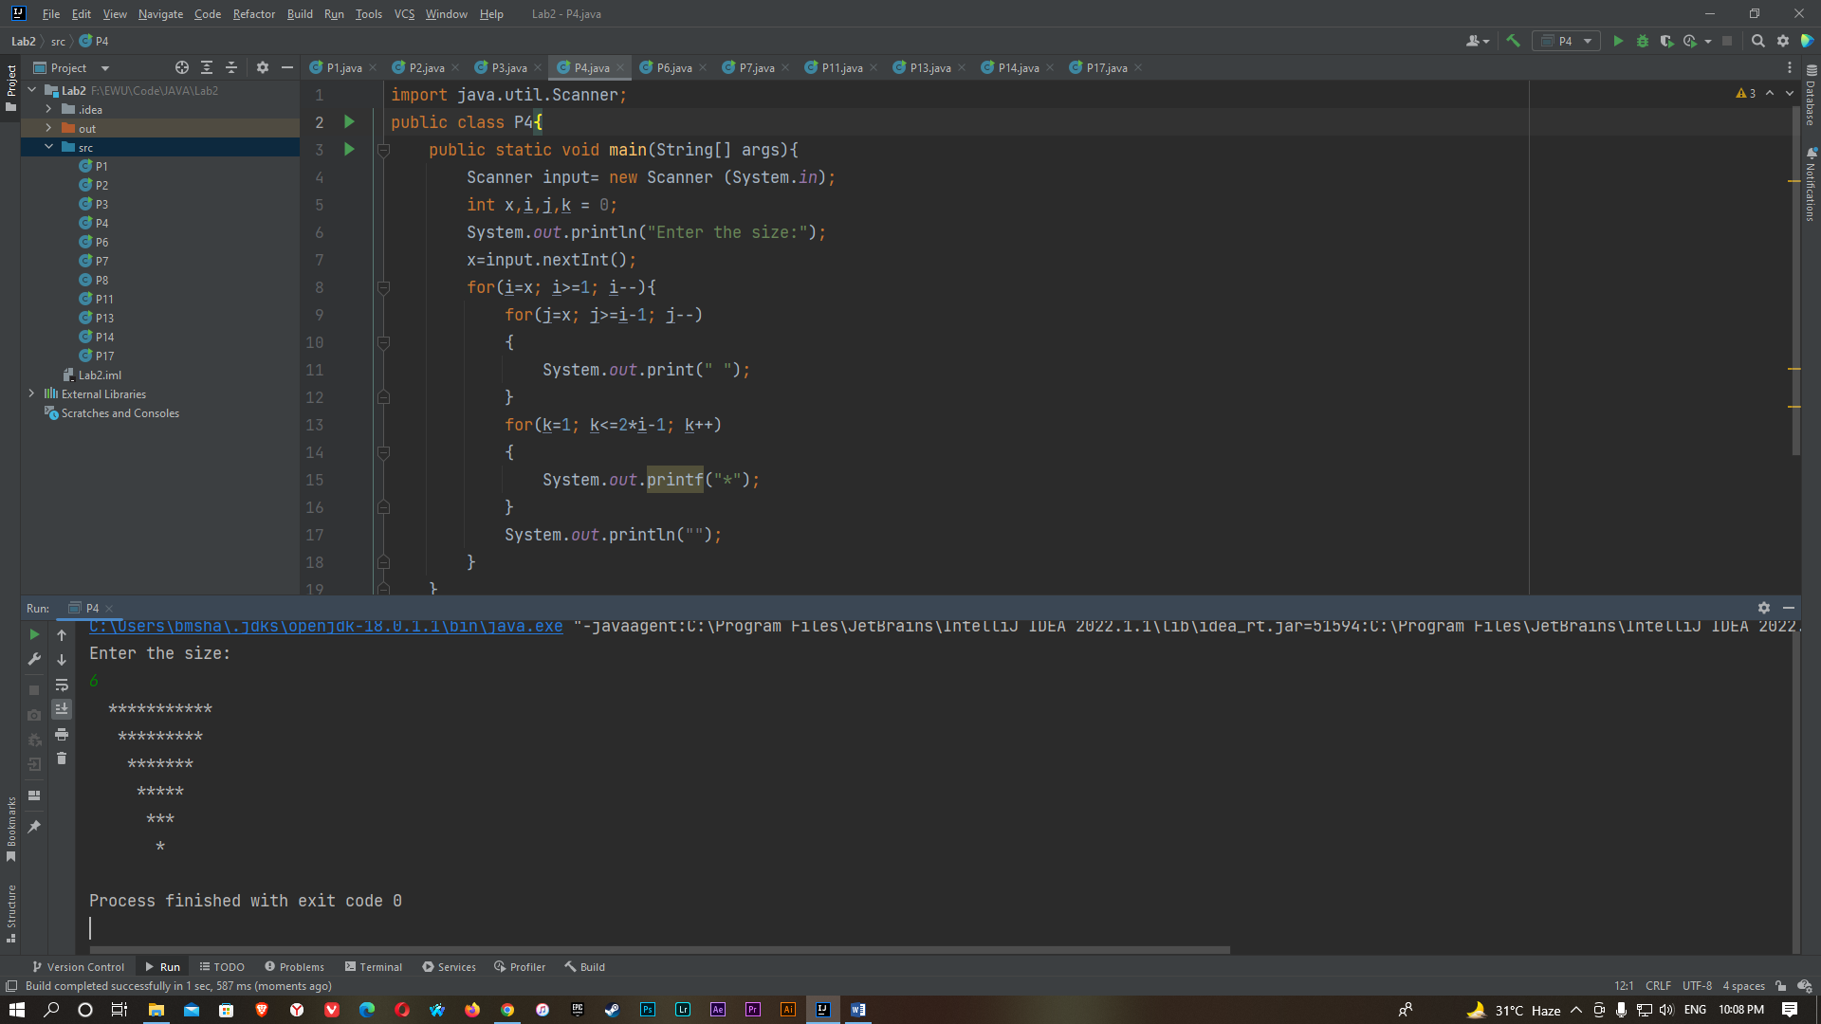

P5

A)

package lab2;

import java.util.Scanner;

public class Pattern5 {

public static void main(String[] args){

Scanner input= new Scanner (System.in);

int x,i,j;

System.out.println("Enter the size:");

x=input.nextInt();

for(i=1; i<=x; i++){

for(j=1; j<=i; j++){

System.out.print(j);

}

System.out.println("");

}

}

}

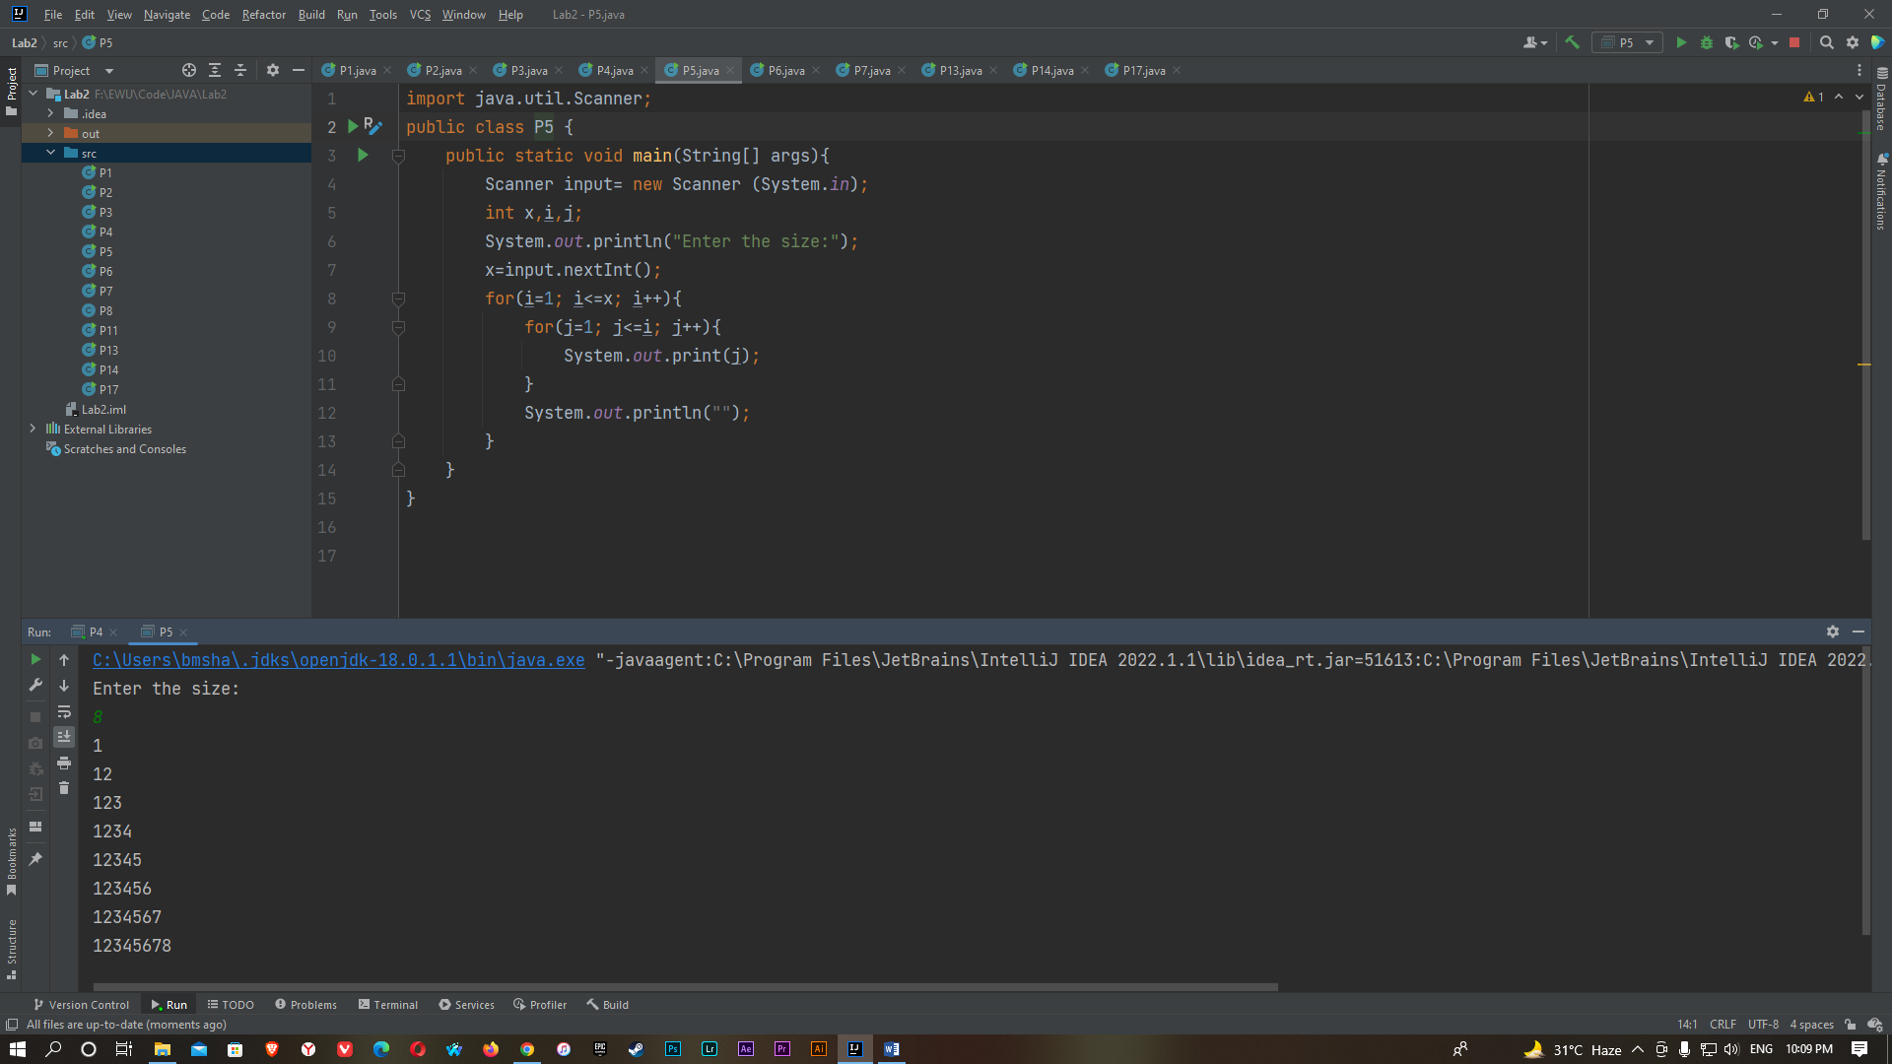

B)

package lab2;

import java.util.Scanner;

public class Pattern5 {

public static void main(String[] args){

Scanner input= new Scanner (System.in);

int x,i,j,k;

System.out.println("Enter the size:");

x=input.nextInt();

for(i=x; i>0; i--){

for(k=x-1; k>=i; k--){

System.out.print(" ");

}

for(j=1; j<=i; j++){

System.out.print(j);

}

System.out.println(" ");

}

}

}

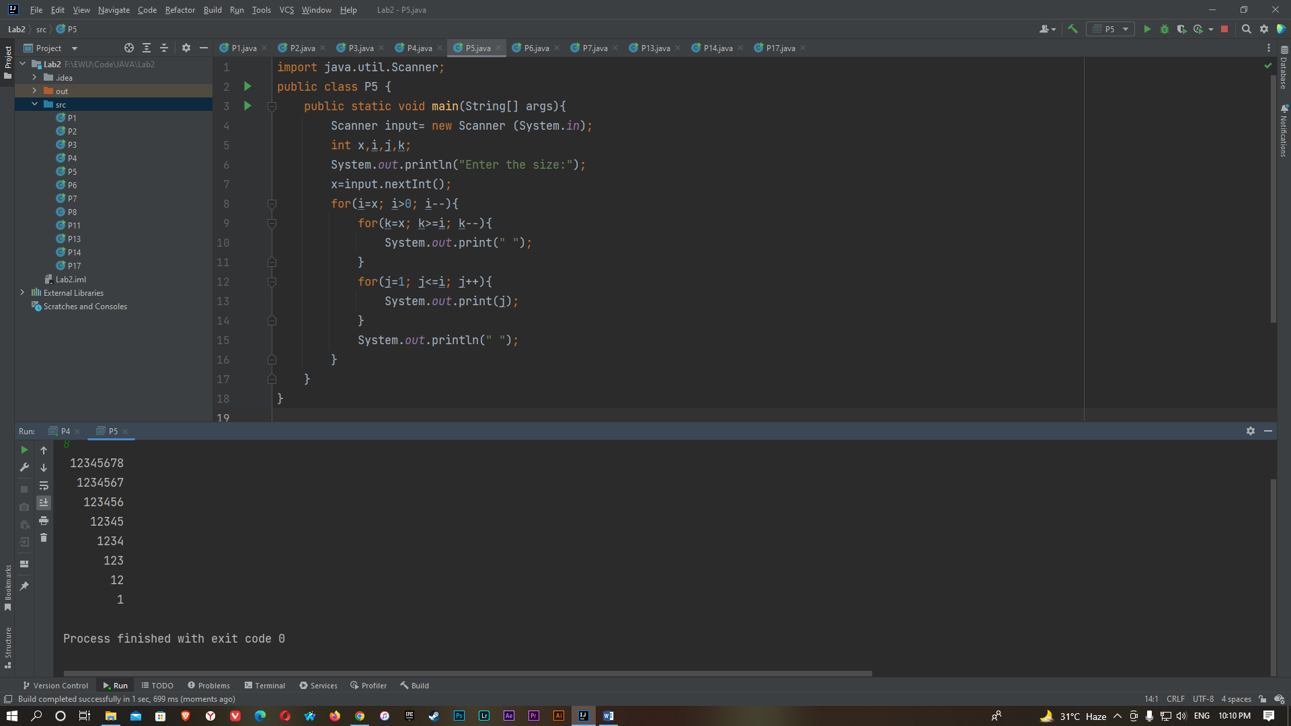

C)

package lab2;

import java.util.Scanner;

public class Pattern5 {

public static void main(String[] args){

Scanner input= new Scanner (System.in);

int x,i,j,k;

System.out.println("Enter the size:");

x=input.nextInt();

for(i=1; i<=x; i++){

for(k=x; k>=i; k--){

System.out.print(" ");

}

for(j=i; j>=1; j--){

System.out.print(j);

}

System.out.println(" ");

}

}

}

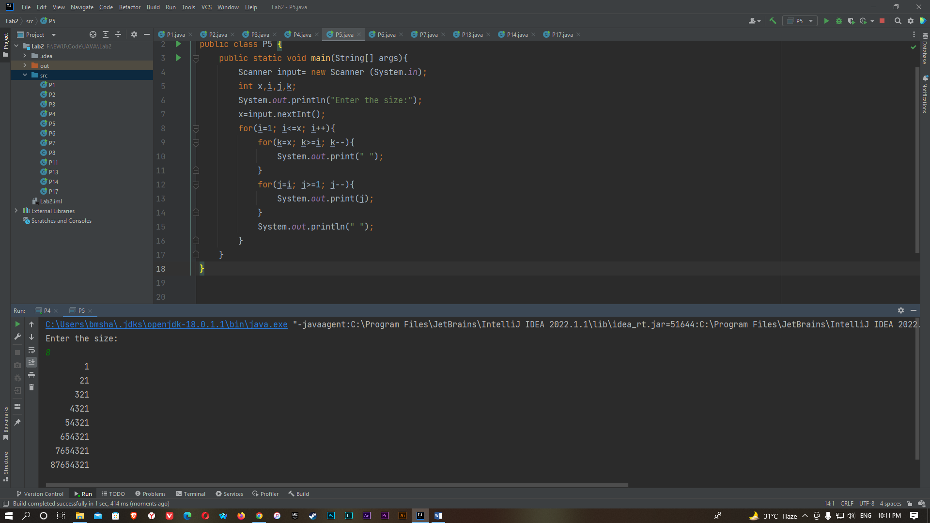

D)

package lab2;

import java.util.Scanner;

public class Pattern5 {

public static void main(String[] args){

Scanner input= new Scanner (System.in);

int x,i,j,k;

System.out.println("Enter the size:");

x=input.nextInt();

for(i=x; i>0; i--){

for(j=i; j>=1; j--){

System.out.print(j);

}

System.out.println(" ");

}

}

}

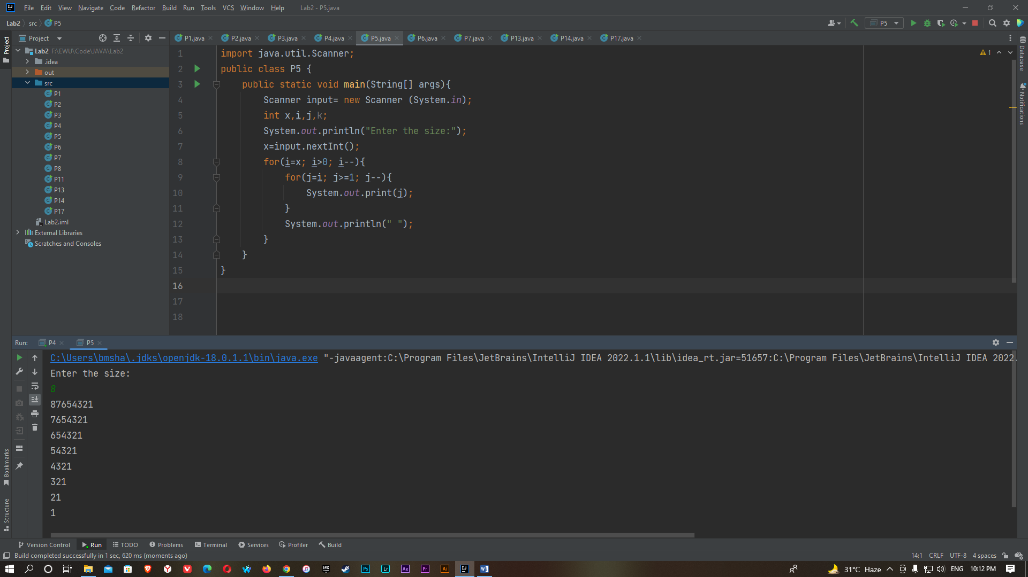

E)

package lab2;

import java.util.Scanner;

public class Pattern5 {

public static void main(String[] args){

Scanner input= new Scanner (System.in);

int x,i,j;

System.out.println("Enter the size:");

x=input.nextInt();

for(i=1; i<=x; i++){

for(j=1; j<=i; j++){

System.out.print("* ");

}

System.out.println("");

}

}

}

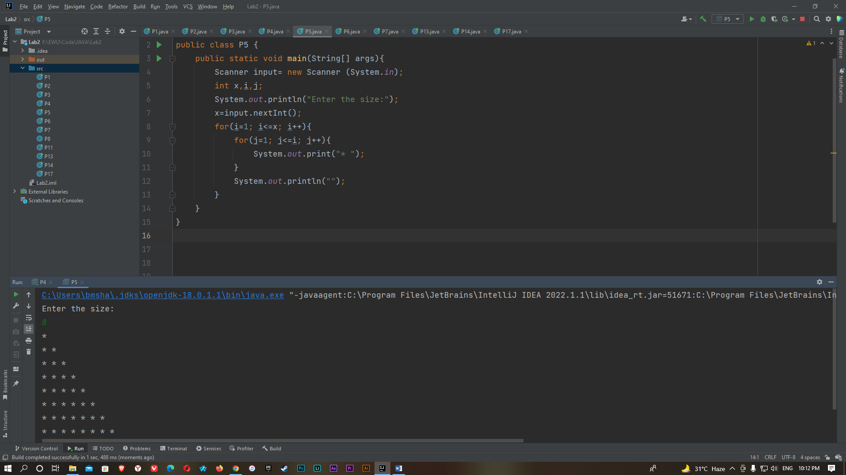

P6)

import java.util.Scanner;

import java.util.Random;

public class P6 {

public static void main(String[] args) {

Scanner input=new Scanner(System.in);

Random ran= new Random ();

int x,y;

y=ran.nextInt(1000);

System.out.println("Enter the number between 0 to 1000: ");

x=1;

while(x>=0)

{

x=input.nextInt();

if (x > y)

{

System.out.println("Too high, try again.");

}

if (x < y)

{

System.out.println("Too low, try again.");

}

if(x==y)

{

System.out.println("Correct Guess!");

break;

}

}

}

}

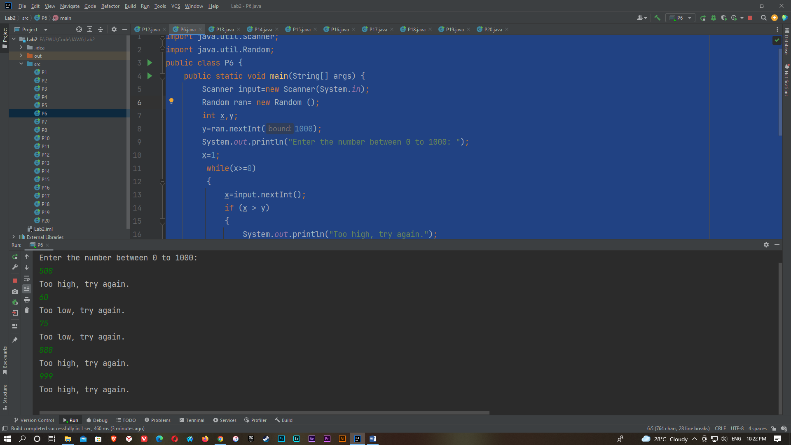

P7)

import java.util.Scanner;

public class P7 {

public static void main(String[] args) {

Scanner input = new Scanner(System.in);

int i,j,k;

for (i=1; i<=7; i++)

{

for (j=1; j<=i; j++)

{

System.out.print(j);

}

for (k=7-i; k>=1; k--)

{

System.out.print("*");

}

System.out.println("");

}

}

}

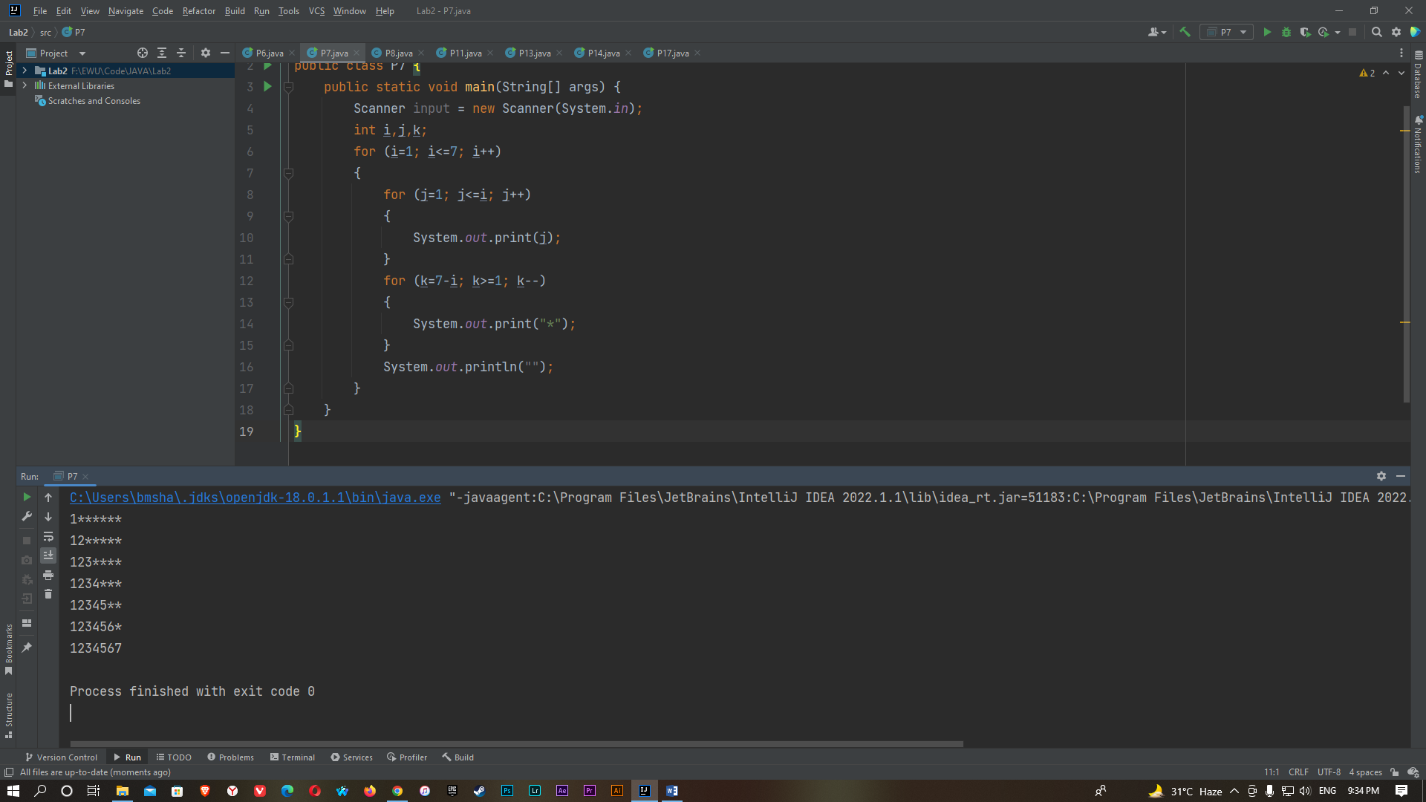

P8)

import java.util.Scanner;

public class P8 {

public static void main(String[] args) {

Scanner input=new Scanner(System.in);

int i;

System.out.println("Enter the Word:");

String x=input.nextLine();

String y="";

for(i=x.length()-1; i>=0; i--)

{

y=y+x.charAt(i);

}

if(x.equals(y))

{

System.out.println("It is a Palindrome.");

}

else

{

System.out.println("Not a Palindrome.");

}

}

}

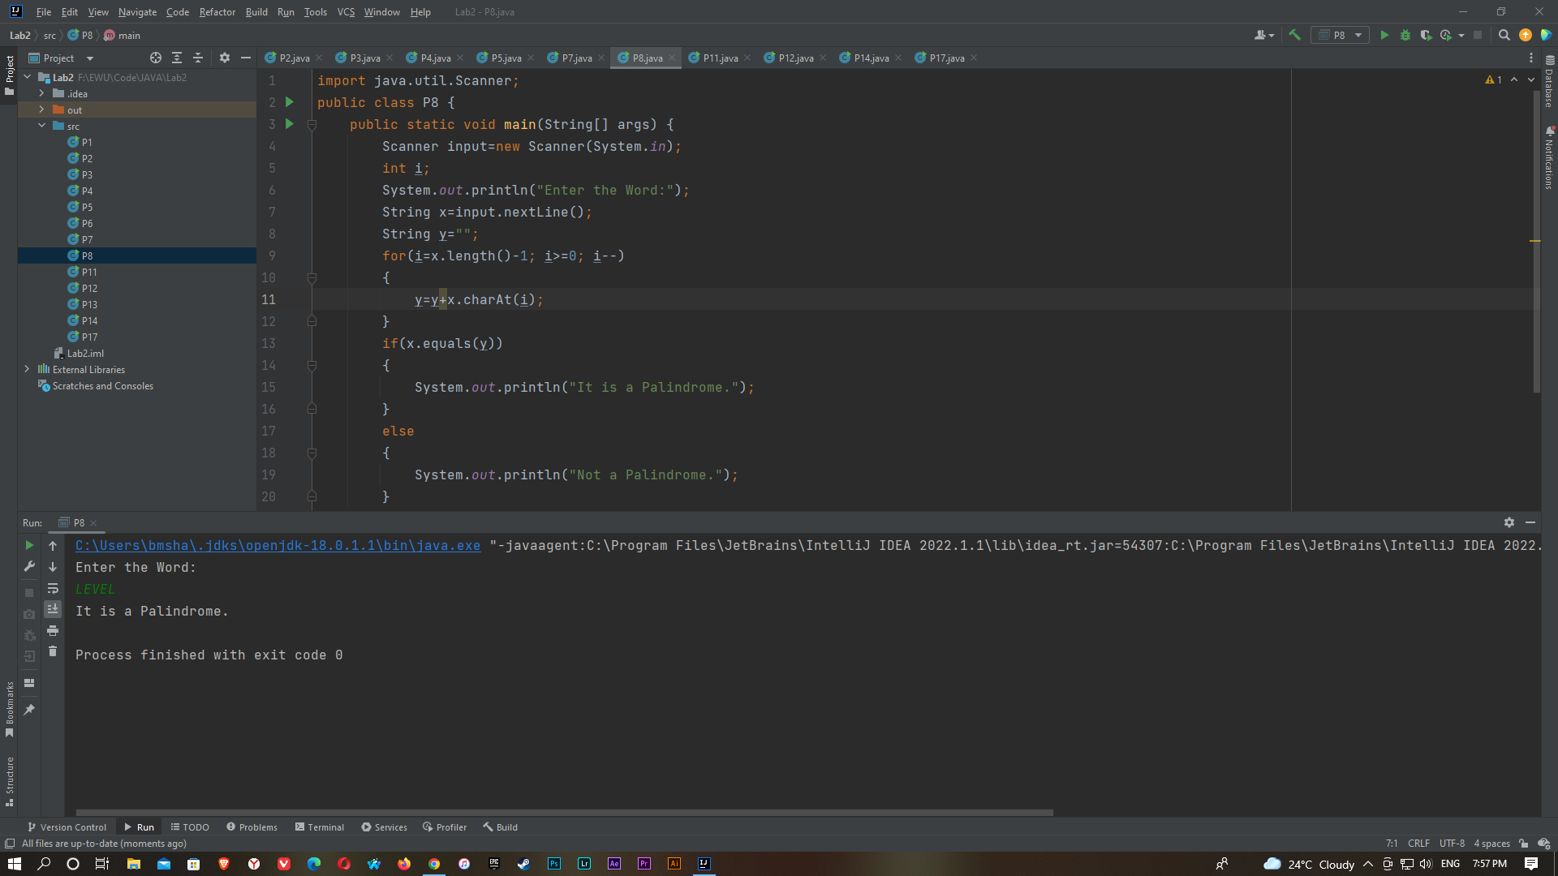

P9)

import java.util.Scanner;

public class ListOfOddAndEven09 {

public static void main(String[] args) {

Scanner input = new Scanner(System.in);

System.out.print("Enter the number of elements you want to store: ");

int n = input.nextInt();

System.out.print("Enter any integer : ");

int[] a = new int[n];

for(int i=0; i<n; i++) {

a[i]=input.nextInt();

}

for(int i=0;i<n;i++){

if(a[i]%2!=0){

System.out.print(a[i]);

}

}

for(int i=0;i<n;i++){

if(a[i]%2==0){

System.out.print(a[i]);

}

}

}

}

P10)

i)(while loop)

import java.util.Scanner;

public class Pattern10Using_While {

public static void main(String[] args) {

Scanner input = new Scanner(System.in);

System.out.print("Enter the size : ");

int n = input.nextInt();

int i=1;

while(i!=n+1){

int j=1,k=1;

while(j<=n-i){

System.out.print(" ");

j++;

}

while(k<i*2){

System.out.print(i);

k++;

}

System.out.print("\n");

i++;

}

}

}

ii) (Using for loop)

import java.util.Scanner;

public class P10 {

public static void main(String[] args)

{

Scanner input=new Scanner(System.in);

int x,i,j,k;

System.out.println("Input the number:");

x=input.nextInt();

for(i=1; i<=x; i++)

{

for(k=x; k>=i; k--)

{

System.out.print(" ");

}

for(j=i; j>=1; j--)

{

System.out.print(j);

}

for(j=2;j<=i;j++)

{

System.out.print(j);

}

System.out.println(" ");

}

}

}

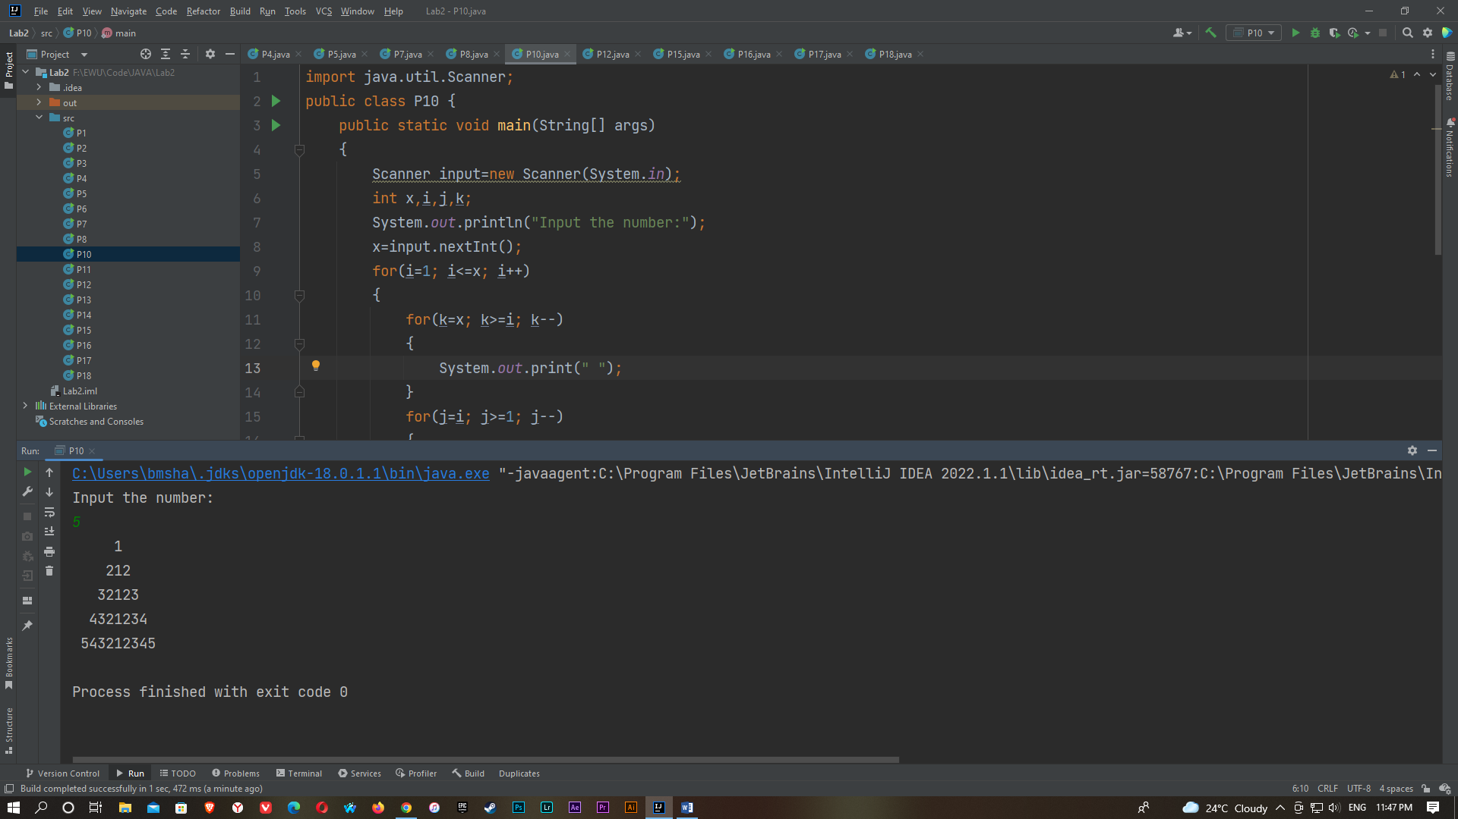

P11)

import java.util.Scanner;

public class P11 {

public static void main(String[] args) {

Scanner xy= new Scanner(System.in);

int n,i;

float a=0;

System.out.println("Enter the number: ");

n =xy.nextInt();

System.out.printf("The sum of the series 1+ ");

for(i=1;i<=n;i++)

{

a=a+(float)1/i;

System.out.printf("1/"+i+"+ ");

}

System.out.printf("= "+a);

}

}

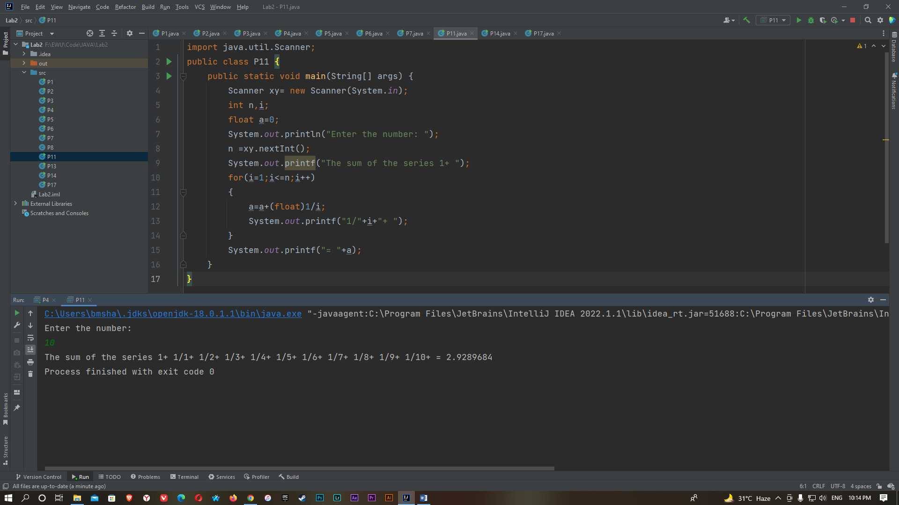

P12)

import java.util.Scanner;

public class P12 {

public static void main(String[] args) {

Scanner input=new Scanner(System.in);

int x,y;

System.out.println("Enter the first number:");

x=input.nextInt();

System.out.println("Enter the second number:");

y=input.nextInt();

System.out.print("GCD of "+x+" and "+y+" is ");

while(x!=y)

{

if(x>y)

{

x=x-y;

}

else

{

y=y-x;

}

}

System.out.print(+x);

}

}

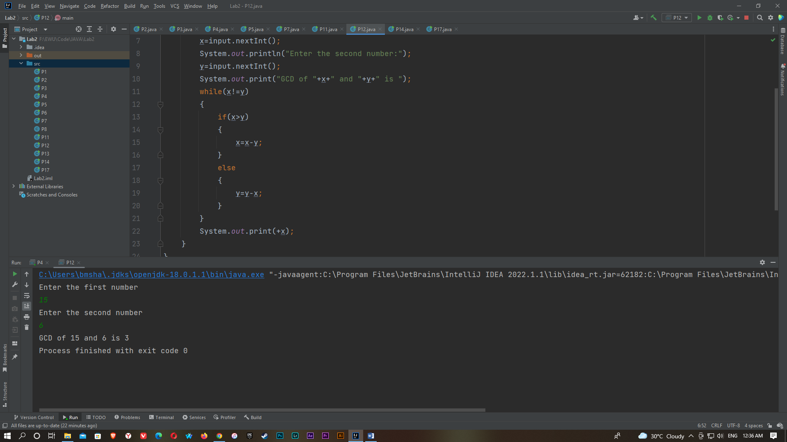

P13)

import java.util.Scanner;

public class P13 {

public static void main(String[] args) {

Scanner input = new Scanner(System.in);

int x,i,j,k,a=1;

System.out.println("Enter the number:");

x=input.nextInt();

for (i=0; i<x;i++)

{

for (j=1; j<=x-i ;j++)

{

System.out.print(" ");

}

for (k=0; k<=i; k++)

{

if (k==0 || i==0)

{

a=1;

}

else

{

a=a*(i-k+1)/k;

}

System.out.printf("%4d",+a);

}

System.out.print("\n");

}

}

}

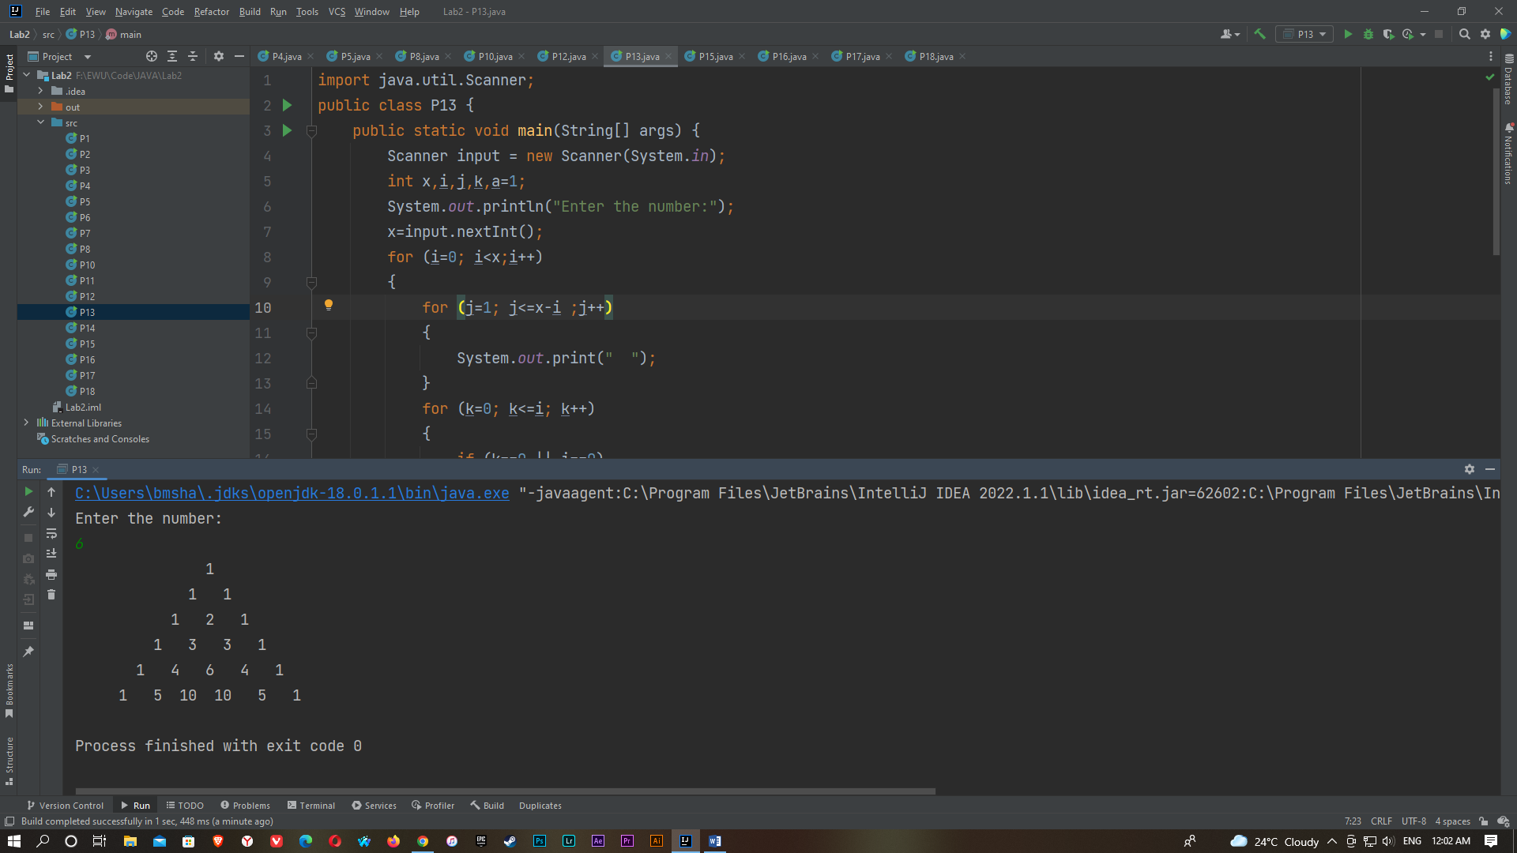

P14)

import java.util.Scanner;

public class P14 {

public static void main(String[] args) {

Scanner input = new Scanner(System.in);

int x, i, j=1;

System.out.println("Enter the number: ");

x=input.nextInt();

for(i=1; i<=x; i++)

{

j=j*i;

}

System.out.println(j);

}

}

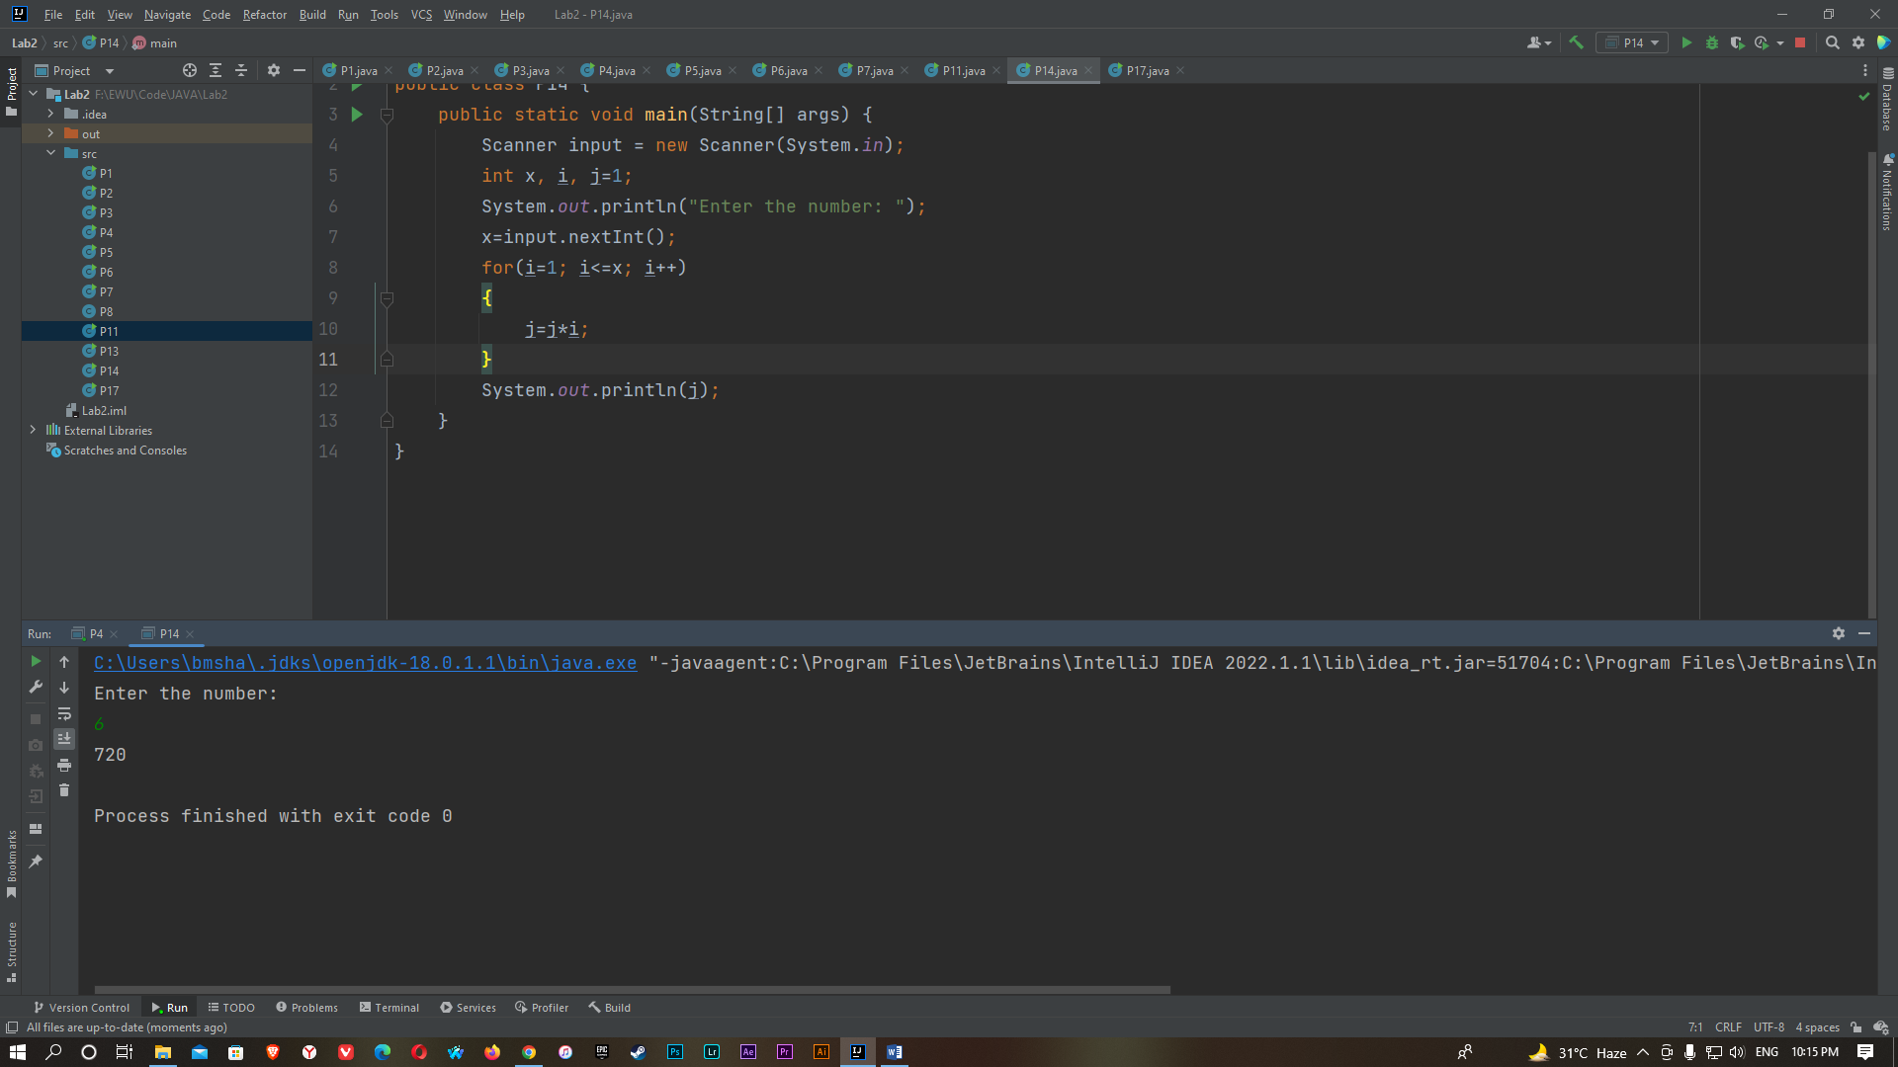

P15)

i) (Using do while loop)

import java.util.Scanner;

public class P15 {

DoWhile {

public static void main(String[] args) {

Scanner input = new Scanner(System.in);

System.out.print("Input number : ");

int num = input.nextInt();

int reversed=0;

do{

int digit = num % 10;

reversed = reversed * 10 + digit;

num /= 10;

}

while(num!=0);

System.out.println("The reversed number is : "+reversed);

}

}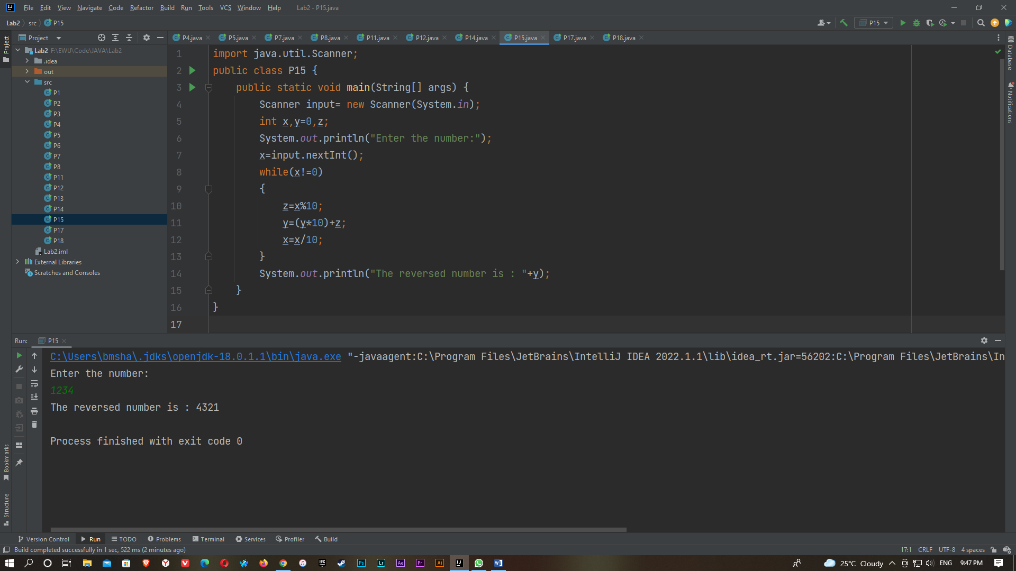

ii) (Using for loop)

import java.util.Scanner;

public class P15 {

public static void main(String[] args) {

Scanner input= new Scanner(System.in);

int x,y=0,z;

System.out.println("Enter the number:");

x=input.nextInt();

for(;x!=0;)

{

z=x%10;

y=(y*10)+z;

x=x/10;

}

System.out.println("The reversed number is : "+y);

}

}

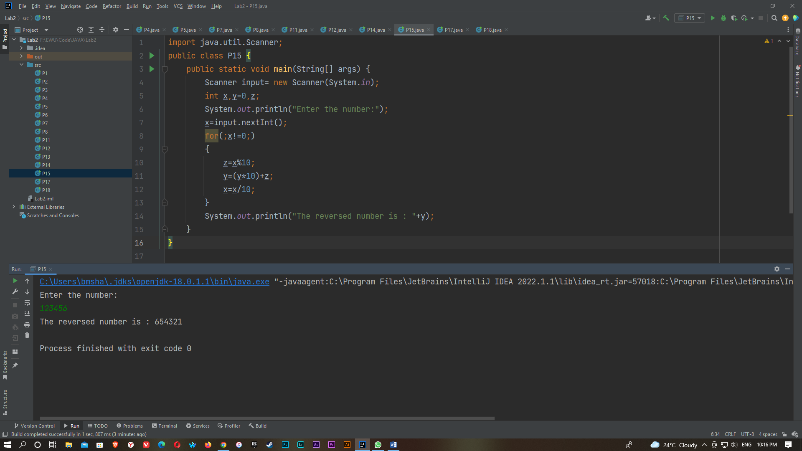

P16)

import java.util.Scanner;

public class P16 {

public static void main(String[] args) {

Scanner input=new Scanner(System.in);

int x,i,j,k;

System.out.println("Input the number:");

x=input.nextInt();

for(i=1; i<=x; i++)

{

for(k=x; k>=i; k--)

{

System.out.print(" ");

}

for(j=i; j>=1; j--)

{

System.out.print(j);

}

for(j=2;j<=i;j++)

{

System.out.print(j);

}

System.out.println(" ");

}

for(i=x-1; i>0; i--)

{

for(k=x; k>=i; k--)

{

System.out.print(" ");

}

for(j=i; j>=1; j--)

{

System.out.print(j);

}

for(j=2; j<=i; j++)

{

System.out.print(j);

}

System.out.println(" ");

}

}

}

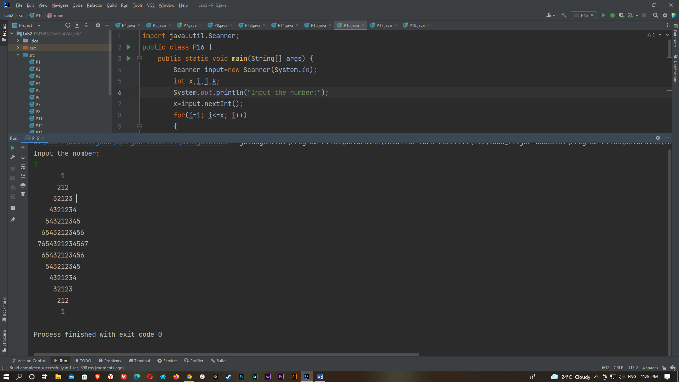

P17)

import java.util.Scanner;

public class P17 {

public static void main(String[] args) {

Scanner input = new Scanner(System.in);

int x;

System.out.println("Enter the number: ");

x = input.nextInt();

if(x==1)

{

System.out.println("Monday");

}

else if(x==2)

{

System.out.println("Tuesday");

}

else if(x==3)

{

System.out.println("Wednesday");

}

else if(x==4)

{

System.out.println("Thursday");

}

else if(x==5)

{

System.out.println("Friday");

}

else if(x==6)

{

System.out.println("Saturday");

}

else

{

System.out.println("Sunday");

}

}

}

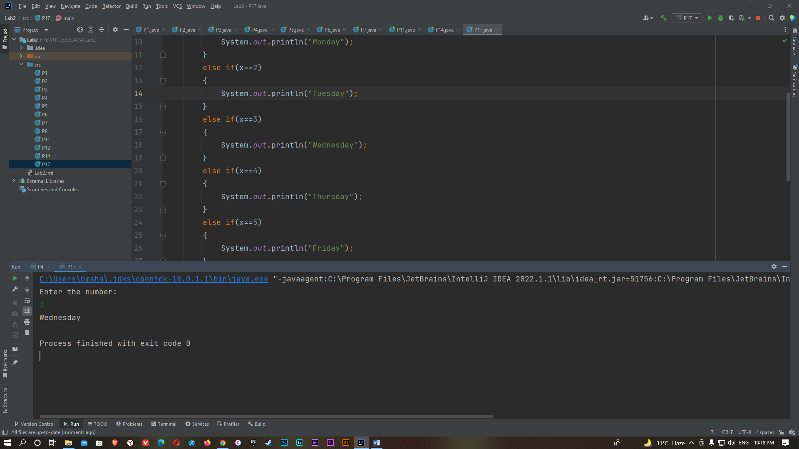

P18)

import java.util.Scanner;

public class P18 {

public static void main(String[] args) {

Scanner input=new Scanner(System.in);

int x;

System.out.println("Enter the year:");

x=input.nextInt();

if(x%4==0)

{

System.out.println(+x+" is a leap year.");

}

else if(x%100==0 || x%400==0)

{

System.out.println(+x+" is a leap year.");

}

else

{

System.out.println(+x+" is not a leap year.");

}

}

}

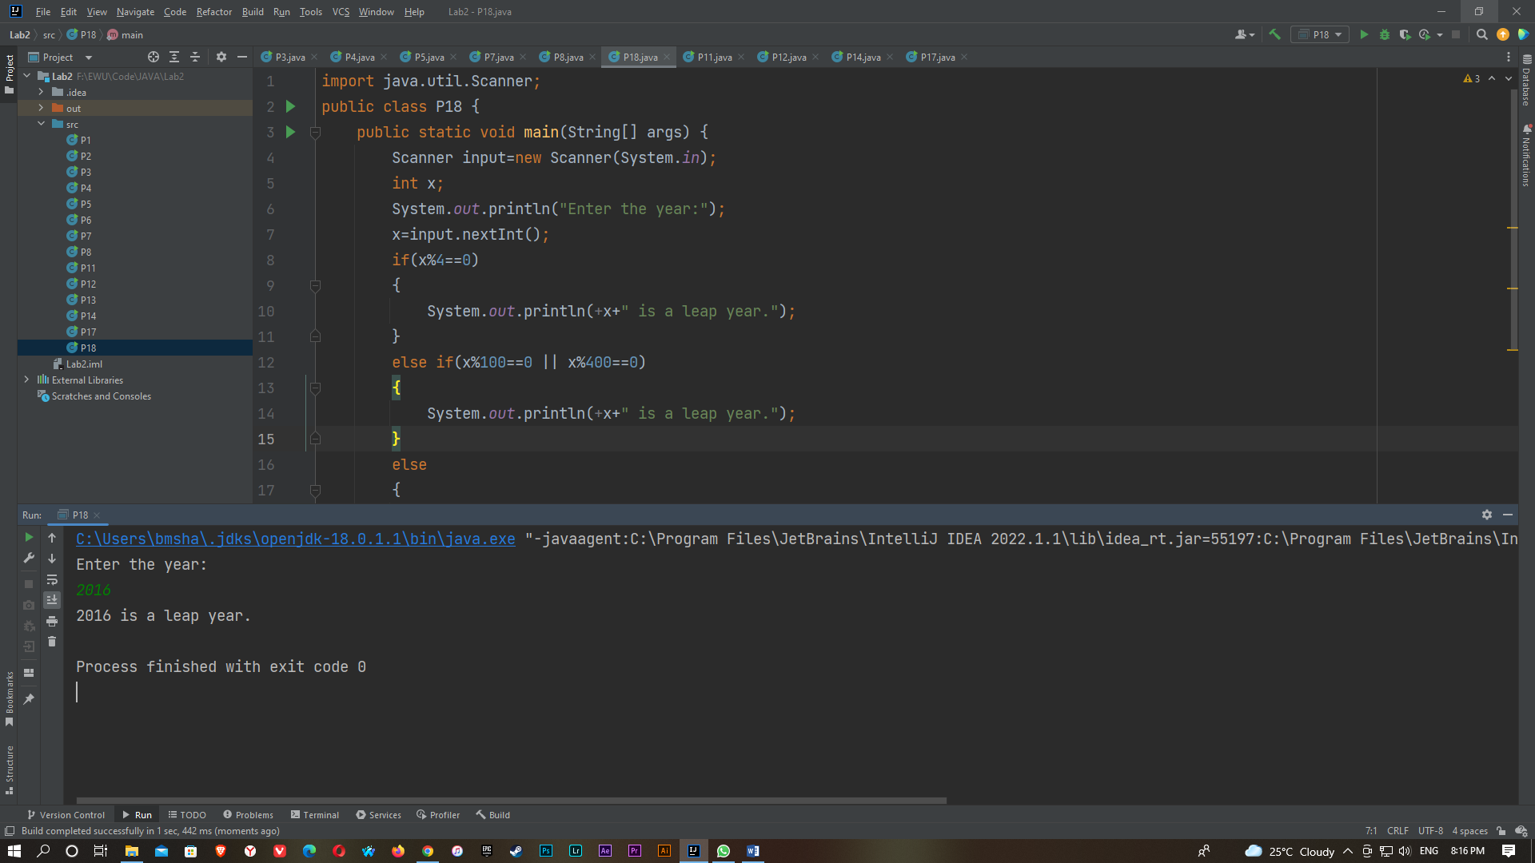

P19)

import java.util.Scanner;

public class P19 {

public static void main(String[] args)

{

Scanner in=new Scanner(System.in);

int n,i,j,a,c=-1,x;

float b,sum=0;

System.out.println("Enter the value of X: ");

x=in.nextInt();

System.out.println("Enter the value of n: ");

n=in.nextInt();

for(i=1;i<=n;i=i+2)

{

a=1;

b=1;

for(j=1;j<=i;j++)

{

b=b*x;

a=a*j;

}

c=-1*c;

sum=sum+(c*b)/(float)a;

}

System.out.println("Sin"+x+"= "+sum);

}

}

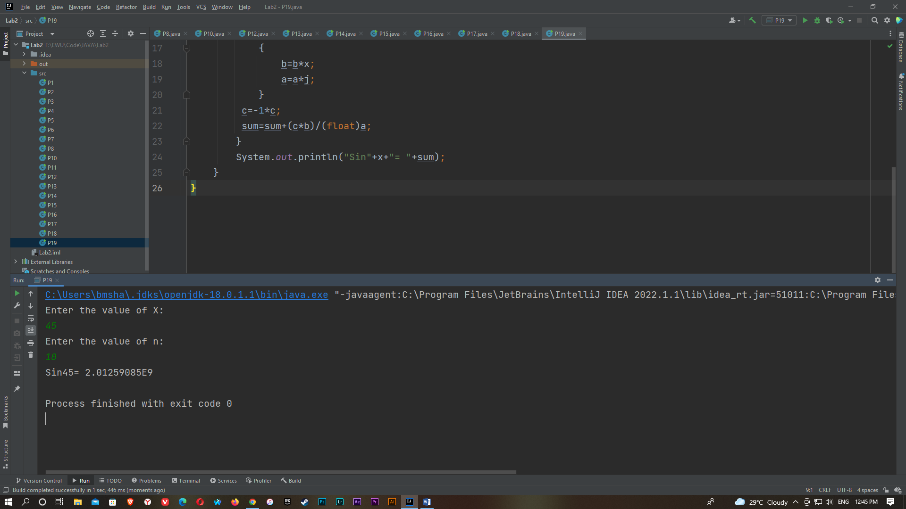

P20)

import java.util.Scanner;

public class P20 {

public static void main(String[] args)

{

Scanner in=new Scanner(System.in);

int n,i,j,a,c=-1,x;

float b,sum=0;

System.out.println("Enter the value of X: ");

x=in.nextInt();

System.out.println("Enter the value of n: ");

n=in.nextInt();

for(i=2;i<=n;i=i+2)

{

a=1;

b=1;

for(j=1;j<=i;j++)

{

b=b*x;

a=a*j;

}

sum=sum+(c*b)/(float)a;

c=-1*c;

}

System.out.println("Cos"+x+"= "+(1+sum));

}

}

